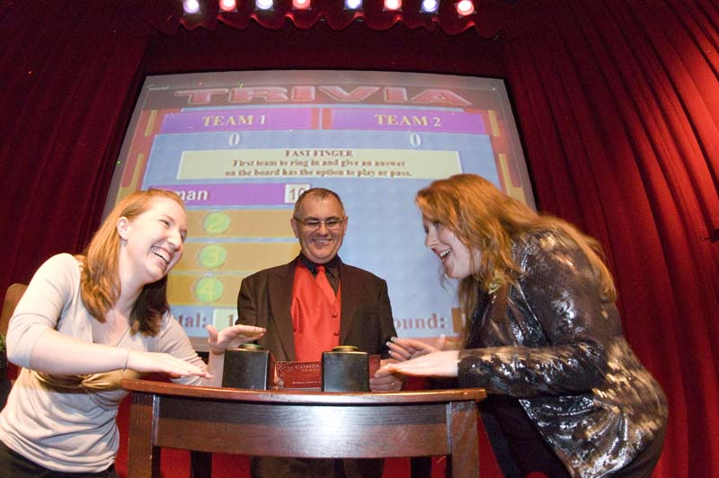
Creating A Unique Event to Build More Customers and Loyal Employees!
What Makes Us Different?
We tailor the event for your company (whether it is a holiday party, training, or simply for fun), creating the style, fun and atmosphere you desire, using audio visual, a PA system, lighting and more.
We provide various means of entertainment, including music, dancing, karaoke, and interactive games.
Games, including game shows like “Minute to Win It”, will create fun for all ages and provide a great way to reinforce corporate training.
A professional DJ in proper attire will act as master of ceremonies for your event, introducing speakers, announcing special events, and coordinating your party.
Special effects lighting can be used to create a theme, enhance the venue, and bring energy and life to the dance floor.
Your employees request the music! We will set up an online request list with over 50,000 songs, allowing guests to request their favorite songs! They can search by song title, artist, or decade, and can even see a tally of their co-workers’ requests. At your event, our DJ will satisfy your guests’ requests and have many other options to choose from. All music is in radio-edited format.

